## **Collision Simulator User Manual**

**Intro to Collision Sim**

Collision Simulator is a program that can reproduce 1-dimensional inelastic, completely inelastic, and elastic collisions, as well as solve for initial or final velocities of the colliding objects.

After running Collision Simulator, you will be presented with an interface:

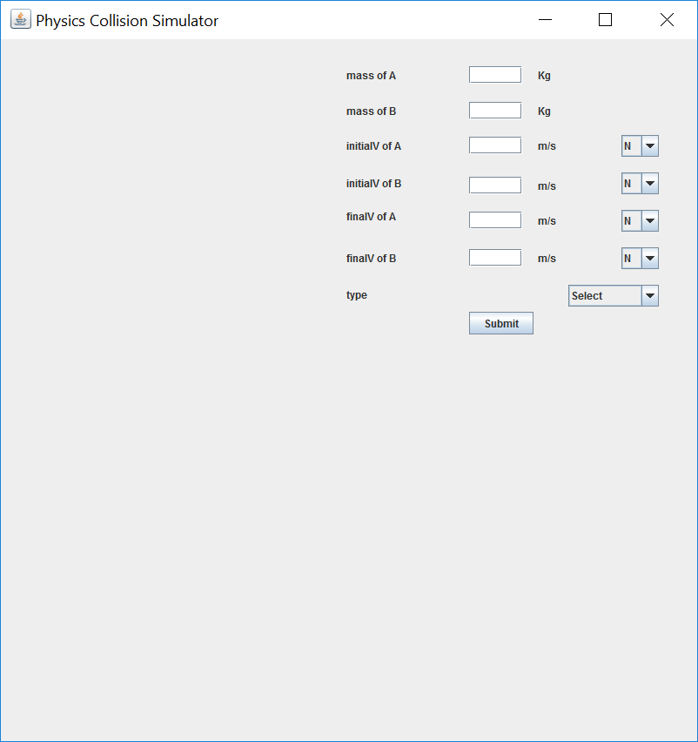

**Submitting Inputs**

Through the interface, you are able to enter data relating to the collision:

*Masses under 50 kg and velocities under 50 m/s are recommended for simulation to be displayed clearly.*

* Mass of Object A **(required)**
* Mass of Object B **(required)**
* Initial velocity of Object A **(required)**
* Initial velocity of Object B **(required)**
* Final velocity of Object A (*any one final velocity required for inelastic*)
* Final velocity of Object B
* Type of collision

The simulation will not run if not enough data is submitted and invalid inputs will not be accepted.

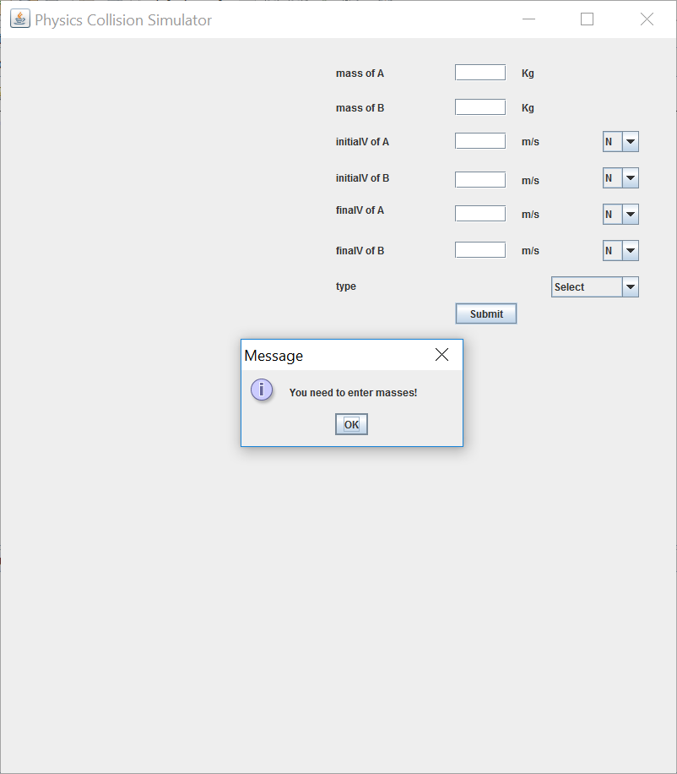

**Types of Collisions**

Completely inelastic:

Two objects collide and stick together, forming a single object. Energy and momentum are conserved. *Only initial velocities are needed.*

Inelastic:

Two objects collide, but do not stick together. Momentum is conserved, but energy is lost (ex. through denting and heat). *Initial velocities are needed as well as any one final velocity.*

Elastic:

Two objects collide and snap back to their original shape. Energy and momentum are conserved. *Only initial velocities are needed.*

*Inputs that are not required for the specific type of collision will be greyed out.*

**Program Output**

After there is enough data submitted to perform calculations, an animated simulation of the collision will appear, as well as any missing velocities that were calculated.

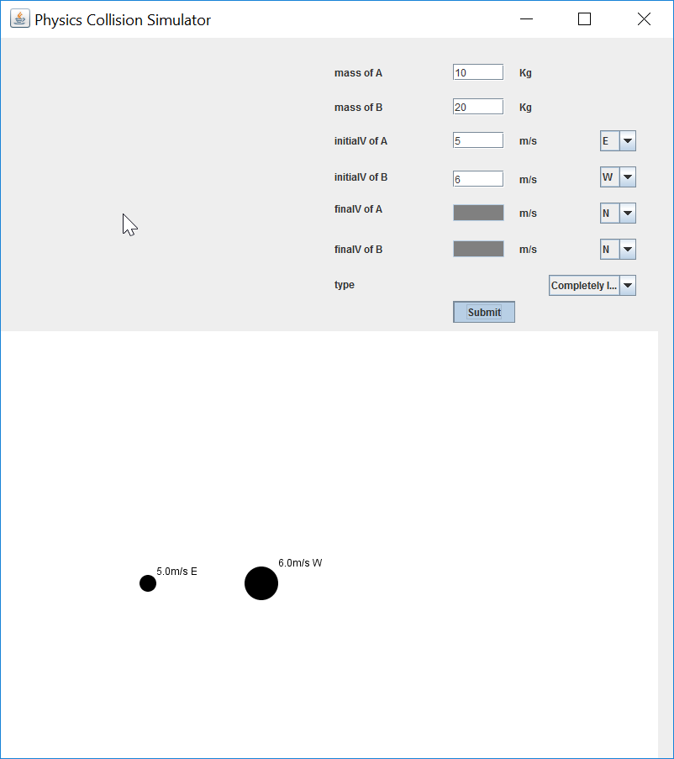

*Objects will appear in the animation, displaying their velocities next to them as they move.*